Overview

Service Management System – Design Document

1. Project Overview (What the system does)
The Service Management System is an on-demand home services platform that connects customers with verified technicians, managed through service managers, under strict admin-controlled pricing and rules.
The platform ensures:
- Standardized services and categories
- Fixed pricing (no negotiation)
- Verified technician onboarding
- Controlled booking, cancellation, payment, and refund flows
- Clear role-based responsibilities

2. Supported Services
The system supports multiple home services:
- Cleaning Services
- Salon at Home
- Electrician Services
- Plumber Services
- Air Conditioner (AC) Services
- Water Purifier Services
- Painting Service
Each Service contains predefined Categories.

Example – Plumber Service
- Installation
- Maintenance
- Repair
This ensures uniform offerings and transparent pricing

Microservices

Microservices Overview

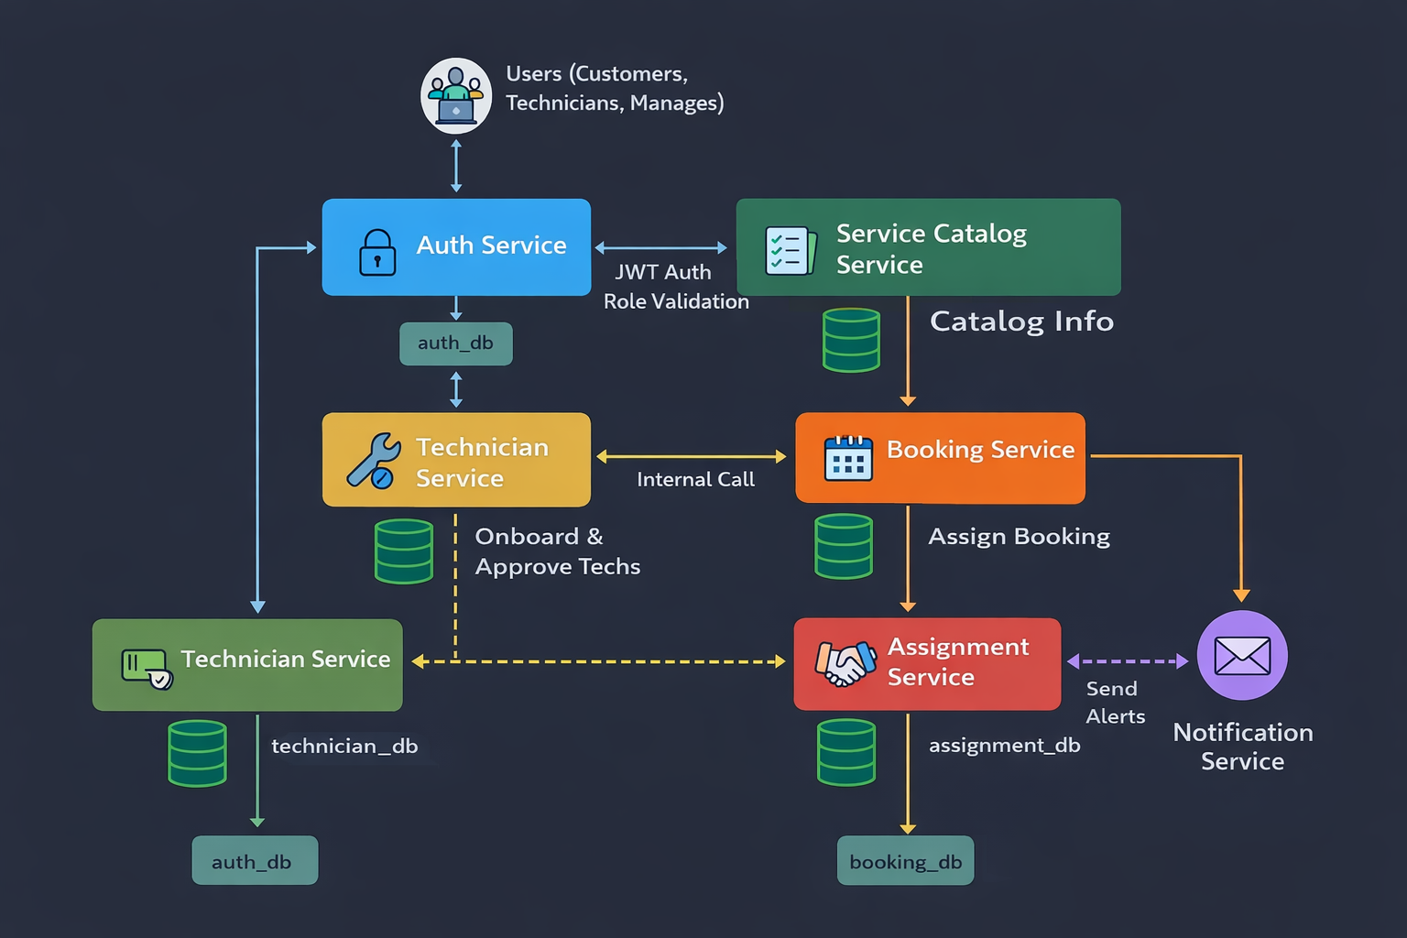

1. Auth Service
Purpose:
Handles authentication and authorization for all users.
Responsibilities:
- User registration & login
- JWT token generation & validation
- Role management (ADMIN, MANAGER, TECHNICIAN, CUSTOMER)
- Secures access to all other services
Every request to other services is authenticated via Auth Service.

2. Technician Service
Purpose:
Manages technician lifecycle and profiles.
Responsibilities:
- Technician registration
- Profile management
- Skill mapping
- Availability status
- Verification status
- Assigned tasks view
- Task progress updates
Only approved technicians are eligible for assignment.
Collection - technicians

3. Notification Service (Async)
Purpose:
Handles all user communications.
Responsibilities:
- Send emails / SMS
- Booking confirmation
- Technician assignment alerts
- Status change notifications
Improves performance by keeping notifications asynchronous.

Triggered by
- Events (or direct calls)
- No db

4. OTP Service
Purpose:
Ensures secure service completion.
Responsibilities:
- Generate OTP for service start / completion
- Verify OTP provided by customer
- Prevent fake or premature service completion
Payment is finalized only after OTP verification.

5. Feedback Service
Purpose:
Collects service quality data.
Responsibilities:
- Store customer ratings & feedback
- Expose technician ratings to managers
- Enable performance evaluation
Helps maintain service quality & accountability.

Service Design: Service Management Service (Operations Core)

1. Service Overview
The Service Management Service is the central orchestrator of the platform. It acts as a "Modular Monolith" within the microservice architecture, combining highly cohesive domains to reduce inter-service latency and data inconsistency. It owns the entire service lifecycle from catalog definition to final reporting .
+3

2. Domain Modules

2.1 Service Catalog Module
Acts as the master data repository for all offerings .
- Responsibilities: * Manage top-level Services (e.g., Plumber, Electrician) .
  - Manage sub-categories with fixed pricing (e.g., Installation, Repair) .
  - Enforce Admin-only control over pricing and discounts .
- Data Model (MongoDB - services collection):
JSON
{
"serviceName": "Plumber",
"description": "Professional plumbing solutions",
"isActive": true,
"categories": [
{ "name": "Installation", "basePrice": 500, "discount": 10 },
{ "name": "Repair", "basePrice": 300, "discount": 0 }
]
}

2.2 Booking & Service Request Module
The unified domain for all customer service requests .
- Responsibilities:
  - Handle creation, cancellation, and rescheduling .
  - Enforce the 24-hour rule: Bookings must be made 24h in advance; cancellations within 24h are restricted .
  - Maintain the State Machine: REQUESTED → ASSIGNED → IN_PROGRESS → COMPLETED → CLOSED.
- Data Model (MongoDB - bookings collection): Includes customer details, location, and the unified lifecycle status .

2.3 Assignment Module (Internal Domain Service)
An internal logic layer that manages technician matching .
- Logic: Triggered automatically upon booking creation.
- Filters: Matches technicians based on Skill, Location, and Availability .
- Benefit: Keeps assignment logic internal to the booking flow, ensuring a technician is secured before the request moves to ASSIGNED.

2.4 Billing & Invoice Module
Manages the financial finalization of the service lifecycle .
- Trigger: Automatically generates an invoice document when booking status changes to COMPLETED.
- Responsibilities:
  - Calculate final amount (Price - Discount).
  - Track payment status: PENDING (COD) or PAID (Prepaid).
- Data Model (MongoDB - invoices collection): Linked to bookingId and customerId.

2.5 Reports & Analytics Module
Provides data-driven insights using read-only aggregation .
- Key Reports:
  - Volume: Service requests grouped by status and category.
  - Performance: Average resolution time and technician workload .
  - Finance: Monthly revenue calculation using sum aggregation.
+1
- Implementation: Uses MongoDB Aggregation Pipelines and Java 8 Streams for high-performance data processing .

Service Name | Key Modules (Internal) | Database
Identity Service | Auth, Roles, Profiles 9 | MongoDB
Service Management | Catalog, Booking, Assignment, Billing, Reports 10 | MongoDB
Technician Service | Onboarding, Skill Map, Availability Tracking 11 | MongoDB
Notification Service | Email/SMS Templates (Async) 12 | N/A (Stateless)

Roles

Roles & Responsibilities

Roles
- Admin
- Service Manager
- Technician
- Customer

Admin Responsibilities
- Create / update / delete services
- Define service categories
- Set base prices & discounts
- Add / remove service managers
- Control pricing (no technician/customer override)

Service Manager Responsibilities
- Approve or reject technician registrations
- View unassigned bookings
- Monitor active bookings
- Track technician workload
- Handle escalations:
  - Reassign technician
  - Cancel booking
  - Trigger refund
- View reports:
  - Completion time
  - Technician performance
  - Customer feedback

Technician Responsibilities
- Register with profile & skills
- Await approval from Service Manager
- Accept / reject assigned bookings
- Update service status
- Complete service using OTP from customer
- View ratings & feedback
- View assigned bookings

Customer Responsibilities
- Register / Login
- Search services by service & location
- Book services
- Make payments (Prepaid / COD)
- Track booking status
- Cancel booking (as per rules)
- Give ratings & feedback

End-to-End Flow
- Admin creates services & categories
- Technician registers → status PENDING
- Service Manager approves technician → status ACTIVE
- Customer books service
- Booking created with status CREATED
- Assignment Service auto-assigns technician
- Technician accepts booking
- OTP sent to customer
- Service performed
- OTP verified → status COMPLETED
- Payment finalized
- Customer submits feedback

Role | Access
ADMIN | Create / Update services
SERVICE_MANAGER | View
CUSTOMER | View
TECHNICIAN | View

Booking

Flow Explanation
- Customer searches service
- Customer creates booking
  - Service
  - Category
  - Date & time (≥ 24 hrs)
  - Location
  - Payment mode (Prepaid / COD)
- Booking created with status → CREATED
- Booking event published
- Assignment Service assigns technician
- Booking status → ASSIGNED
- Technician accepts booking
- Booking status → ACCEPTED
- OTP sent to customer
- Service performed
- OTP verified
- Booking status → COMPLETED
- Payment finalized
- Feedback enabled

Technician Assignment
- Assignment Service listens to booking events
- Filters technicians by:
  - Skill (service category)
  - City / location
  - Status = ACTIVE
- Load-balancing logic applied
- Technician assigned
- Assignment stored
- Booking updated → ASSIGNED
- Technician notified

Accept Flow
- Technician views assigned booking
- Accepts booking
- Booking status → ACCEPTED
- OTP generated & sent to customer

Reject Flow
- Technician rejects booking
- Assignment marked → REJECTED
- New assignment triggered
- Booking remains → CREATED / ASSIGNED

Service Execution & OTP Workflow
Technician reaches customer
OTP generated for service completion
Customer shares OTP
OTP verified
Booking status → COMPLETED
Payment finalized
Feedback enabled

Cancellation
Customer requests cancellation
Booking Service checks:
- Is within 24 hours?
If within 24 hrs
- Cancellation rejected
If allowed
- Status → CANCELLED
- Refund logic applied:
  - Prepaid → 50% refund
  - COD → no charge

Business Rules

Business Rules

Booking & Cancellation
- Booking must be made at least 24 hours in advance
- Booking cannot be cancelled within 24 hours of service time
- If cancellation is allowed:
  - Prepaid → 50% refund
  - COD → No charge

Pricing
- Fixed & transparent pricing
- No negotiation with technicians
- Prices controlled only by Admin

Technician Approval
- Technician must be approved by Service Manager
- Only approved technicians can be assigned bookings

Payment
- Payment modes:
  - Prepaid (Online)
  - Cash on Delivery (COD)
- Payment marked completed only after service completion + OTP
- Refunds applicable only for prepaid bookings

Api Endpoints

API Endpoints

Auth & User Service APIs
Method | Endpoint | Description | Access Level
POST | /api/auth/register | Creates a new user account with a specific role and profile details³. | Public
POST | /api/auth/login | Validates credentials and returns a JWT Token for session management⁴⁴⁴⁴⁴⁴⁴⁴⁴.  +4 | Public
GET | /api/auth/me | Retrieves the current authenticated user's profile and role information⁵. | Authenticated

Public :
POST /api/auth/register → CUSTOMER, TECHNICIAN
POST /api/auth/login

Protected:
GET /api/auth/me → Logged-in user info
POST /api/auth/create-manager → ADMIN only

Jwt content : {
"userId": "abc123",
"email": "user@email.com",
"role": "CUSTOMER
Booking / Service Request APIs

Method | Endpoint | Description | Access Level
POST | /api/bookings | Creates a new service request with specific category, date, and location³³³³.  +1 | Customer
GET | /api/bookings/{id} | Retrieves full details of a specific booking, including status and assigned technician⁴⁴⁴⁴.  +2 | All Roles (Owner/Admin)
GET | /api/bookings/my | Lists all service history and active requests for the logged-in user⁵⁵⁵⁵.  +1 | Customer
GET | /api/bookings/manager | Lists all bookings (Assigned/Unassigned) within the manager's jurisdiction ⁶⁶⁶⁶.  +1 | Service Manager
PUT | /api/bookings/{id}/cancel | Cancels a booking; enforces the 50% refund rule if cancelled >24h in advance ⁷⁷⁷⁷.  +2 | Customer / Manager
PUT | /api/bookings/{id}/reschedule | Updates the scheduledDateTime if the request is made >24h before the original slot⁸⁸⁸⁸.  +1 | Customer
PUT | /api/bookings/{id}/status | Updates the state (e.g., IN_PROGRESS to COMPLETED) based on OTP verification ⁹⁹⁹⁹.  +1 | Technician / Manager

Technicians
Method | Endpoint | Description | Access Level
POST | /api/technicians/register | Initial technician onboarding with skills and documents²²²².  +1 | Public / Technician
GET | /api/technicians/pending | Lists all technicians awaiting verification³. | Service Manager ⁴
PUT | /api/technicians/{id}/approve | Updates status to ACTIVE, enabling them for assignments⁵. | Service Manager ⁶
PUT | /api/technicians/{id}/status | Updates availability (e.g., AVAILABLE, BUSY, ON_LEAVE)⁷. | Technician / Manager
GET | /api/technicians/{id}/tasks | Retrieves all current and past service bookings for a specific tech⁸⁸.  +1 | Technician / Manager
PUT | /api/technicians/{id}/tasks/{id}/progress | Updates the status of an active job (e.g., IN_PROGRESS)⁹⁹⁹⁹.  +1 | Technician

/api/technicians/onboard
{
"name": "Rahul Kumar",
"email": "rahul@gmail.com",
"phone": "9876543210",
"city": "Bangalore",
"skills": ["PLUMBING"],
"experienceYears": 3
}

/api/technicians/{technicianId}/documents
aadhaar: file
certificate: file

/api/technicians
status=PENDING | APPROVED | REJECTED
city=Bangalore
skill=PLUMBING

/api/technicians/{technicianId}/reject

Technician Profile (Post-Login)
/api/technicians/by-user/{userId}

/api/technicians/{technicianId}/availability
{
"availability": "UNAVAILABLE"
}

/api/technicians/search
skill=PLUMBING
city=Bangalore
availability=AVAILABLE
status=APPROVED

Service Catalog APIs (Admin + Customer)
Method | Endpoint | Description | Access Level
POST | /api/services | Creates a new service (e.g., AC Service) with nested categories and fixed pricing ³³³³.  +2 | Admin
GET | /api/services | Retrieves the list of all active services and categories for the storefront⁴⁴.  +1 | All Roles
GET | /api/services/{id} | Fetches detailed information, descriptions, and price tiers for a specific service⁵⁵.  +1 | All Roles
PUT | /api/services/{id} | Updates service details, pricing, or toggles the isActive status⁶⁶⁶⁶.  +1 | Admin

Reports APIs (Read-only)
Method | Endpoint | Description | Key Data Returned
GET | /api/reports/bookings/status | Counts service requests by their current lifecycle state²²²².  +2 | Total counts for REQUESTED, ASSIGNED, COMPLETED, etc.
GET | /api/reports/bookings/category | Aggregates service requests based on the service category³³³³.  +1 | Request volume per category (e.g., Plumber vs. Electrician).
GET | /api/reports/technician/workload | Tracks the number of active tasks assigned to each technician⁴⁴⁴⁴.  +1 | Technician Name, ID, and count of ASSIGNED/IN_PROGRESS tasks.
GET | /api/reports/revenue/monthly | Calculates total earnings for the current and previous months⁵⁵⁵⁵.  +1 | Sum of all PAID invoices within a 30-day window.
GET | /api/reports/avg-resolution-time | Measures the average time from REQUESTED to COMPLETED⁶. | Time in hours/days filtered by service category or technician.

Database Design & Schemas

Database Design & Schemas

Collection | Owner Service
users | Auth Service
services | Service Management
bookings | Service Management
invoices | Service Management
technicians | Technician Service
feedback | Service Management
notification_logs | Notification Service

Auth Service

Table | Columns
UserCredentials | id (PK), email (Unique), passwordHash, role (ENUM), isActive, createdAt, updatedAt
UserProfile | id (PK), userId (FK), firstName, lastName, phoneNumber, address, city, zipCode

Service Catalog Service

Table | Columns
Service | id (PK), name, description, iconUrl, isActive
Category | id (PK), serviceId (FK), name, description, basePrice, discountPercentage, isActive

Service
id (PK)
name
description
isActive

Category
id (PK)
serviceId (FK)
name
description
basePrice
discountPercentage
isActive

Technician Service

Table | Columns
Technician | id (PK), userId (FK), aadhaarNumber, panNumber, experienceYears, status (PENDING/ACTIVE/BLOCKED)
TechnicianSkill | id (PK), technicianId (FK), categoryId (FK to Catalog)
TechnicianDocument | id (PK), technicianId (FK), documentType, documentUrl, isVerified

Technician
id (PK)
userId (FK → UserCredentials)
experienceYears
city
status (PENDING / ACTIVE / BLOCKED)

TechnicianSkill
id (PK)
technicianId (FK)
skillName

TechnicianDocument
id (PK)
technicianId (FK)
documentType
documentUrl

Booking Service

Table | Columns
Booking | id (PK), customerId (FK), serviceId (FK), categoryId (FK), technicianId (FK, Nullable), totalPrice, status (ENUM), scheduledDateTime, location, createdAt
BookingHistory | id (PK), bookingId (FK), status, remarks, updatedBy, updatedAt

Booking
id (PK)
customerId
serviceId
categoryId
technicianId (nullable)
status (CREATED / ASSIGNED / ACCEPTED / COMPLETED / CANCELLED)
scheduledDateTime
location
price
createdAt

BookingStatusHistory
id (PK)
bookingId
status
remarks
updatedBy
updatedAt

Assignment Service

Table | Columns
Assignment | id (PK), bookingId (FK), technicianId (FK), status (ASSIGNED/ACCEPTED/REJECTED), assignedAt
OtpVerification | id (PK), bookingId (FK), otpCode, type (START/COMPLETE), expiresAt, isVerified

TechnicianAssignment
id (PK)
bookingId
technicianId
assignedAt
status (ASSIGNED / ACCEPTED / REJECTED)

OTP Service
OtpVerification
id (PK)
bookingId
otpCode
type (SERVICE_START / SERVICE_COMPLETE)
expiresAt
verified

Feedback Service

Table | Columns
Feedback | id (PK), bookingId (FK), customerId (FK), technicianId (FK), rating (1–5), comment, createdAt

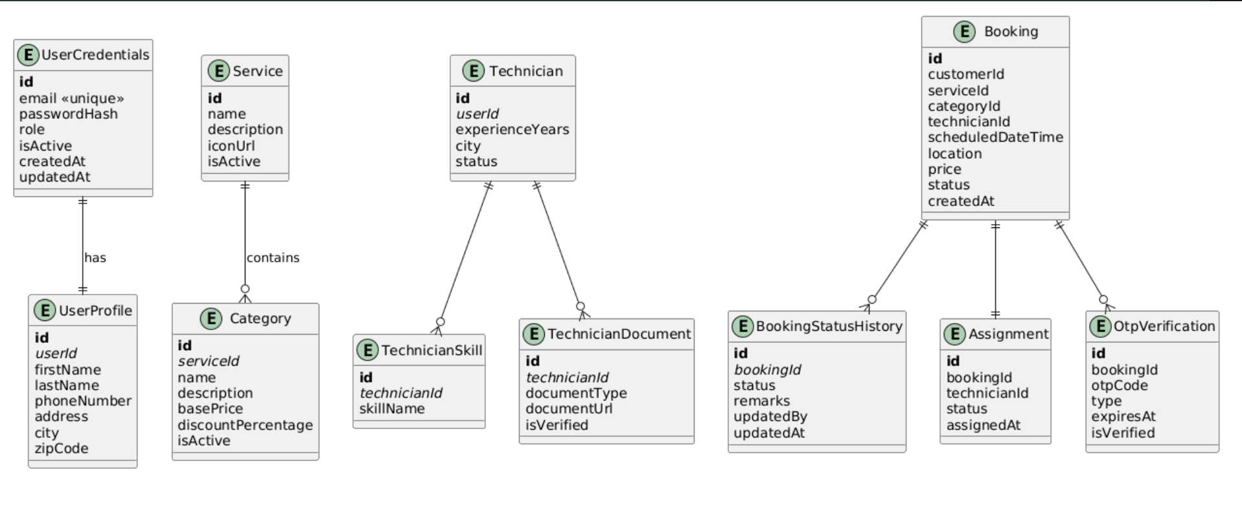
Users collection :
{
"_id": "ObjectId",
"email": "user@email.com",
"passwordHash": "hashedPassword",
"role": "ADMIN | SERVICE_MANAGER | TECHNICIAN | CUSTOMER",
"isActive": true,
"createdAt": "ISODate",
"updatedAt": "ISODate"
}

Optional
- refresh_tokens
- password_reset_tokens

Collection : services
{
"_id": "ObjectId",
"serviceName": "Plumber",
"description": "Plumbing services",
"categories": [
{
"categoryId": "UUID",
"name": "Installation",
"basePrice": 500,
"isActive": true
},
{
"categoryId": "UUID",
"name": "Repair",
"basePrice": 300,
"isActive": true
}
],
"isActive": true,
"createdAt": "ISODate"
}

Bookings collection
{
"_id": "ObjectId",
"customerId": "USER_ID",
"serviceId": "SERVICE_ID",
"categoryId": "CATEGORY_ID",
"scheduledDateTime": "ISODate",
"address": {
"city": "Bangalore",
"area": "HSR Layout",
"fullAddress": "..."
},
"status": "REQUESTED",
"statusHistory": [
{
"status": "REQUESTED",
"timestamp": "ISODate"
}
],
"technicianId": null,
"price": 500,
"paymentMode": "PREPAID | COD",
"createdAt": "ISODate"
}

Booking Status Enum
REQUESTED
ASSIGNED
IN_PROGRESS
COMPLETED
CANCELLED
CLOSED

Invoices Collection - Invoice is generated when booking → COMPLETED
{
"_id": "ObjectId",
"bookingId": "BOOKING_ID",
"customerId": "USER_ID",
"technicianId": "TECH_ID",
"amount": 500,
"paymentStatus": "PENDING | PAID",
"paymentMode": "PREPAID | COD",
"generatedAt": "ISODate"
}

Feedback collection
{
"_id": "ObjectId",
"bookingId": "BOOKING_ID",
"customerId": "USER_ID",
"technicianId": "TECH_ID",
"rating": 4,
"comment": "Good service",
"createdAt": "ISODate"
}

Technicians - Documents stored as URLs — not binary data
{
"_id": "ObjectId",
"userId": "USER_ID",
"name": "Rahul",
"skills": [
{
"serviceId": "SERVICE_ID",
"categoryId": "CATEGORY_ID"
}
],
"city": "Bangalore",
"status": "AVAILABLE | BUSY | ON_LEAVE",
"verificationStatus": "PENDING | APPROVED | REJECTED",
"documents": [
{
"type": "AADHAAR",
"documentUrl": "/uploads/aadhaar.pdf",
"verified": true
}
],
"createdAt": "ISODate"
}

notification_logs
{
"_id": "ObjectId",
"userId": "USER_ID",
"type": "EMAIL | SMS",
"message": "Booking confirmed",
"sentAt": "ISODate",
"status": "SENT | FAILED"
}

